**Obtaining 100 Cell LA model and 1000 Cell BLA model in Sim Agent MPI**

1. Using the latest version of Sim Agent MPI from <https://tjbanks.github.io/SimAgentMPI/>
2. Update by going to Help -> Update

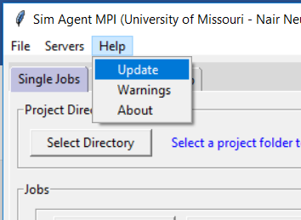

1. In the branch entry box type ‘100la’ (without the quotes) for the 100 Cell LA model.

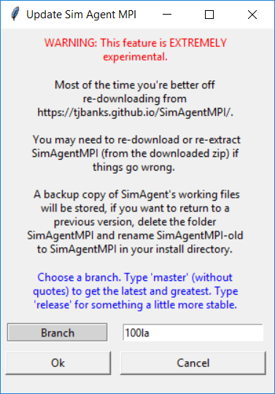

1. There will be a series of prompts confirming your choices,
2. The display may temporarily become unresponsive while downloading. This shouldn’t take too long though.
3. You will need to **relaunch** Sim Agent MPI after it closes.

**(Later) For the next project**

Type ‘1000bla’ (without the quotes) in the update field for the 1000 Cell BLA model

**Things to note**: If you switch branches from 100la to 1000bla (or the other way around) any saved jobs will be lost unless you copy them in Windows file explorer. (saving jobs may not be necessary though)

**Using the new models**

1. Edit parameters using the ‘Parameter Tuning‘ tab. Any changes will be immediately saved to model configuration files. Parameters can be reset to the original value when Sim Agent was opened.

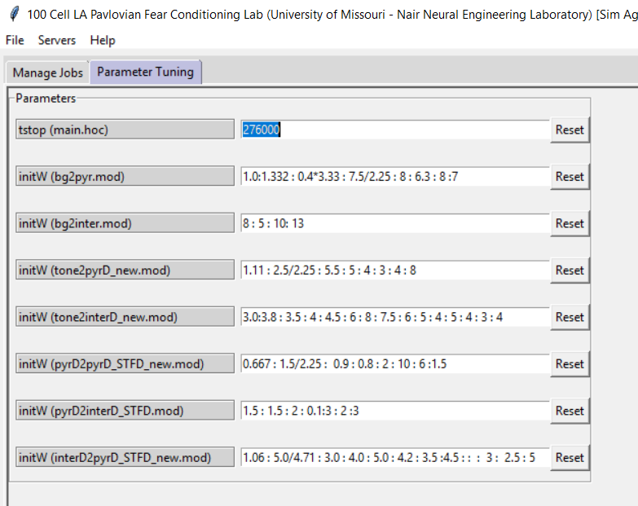

1. Return to the ‘Manage Jobs’ tab and submit a job with these new parameters.
2. Upon job completion click ‘Run Custom Tool’ to view the output of the matlab scripts.